**COMP 20063 | DATA STRUCTURES AND ALGORITHM**

**Name:** Avila, Dariel V. **Date:** October 28, 2022

**Course/Year:** DICT 2-1

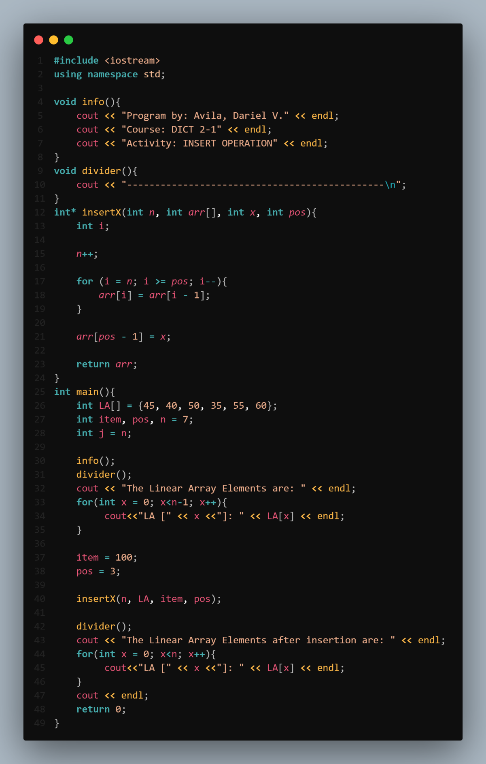Activity 1: **INSERTION – Array**

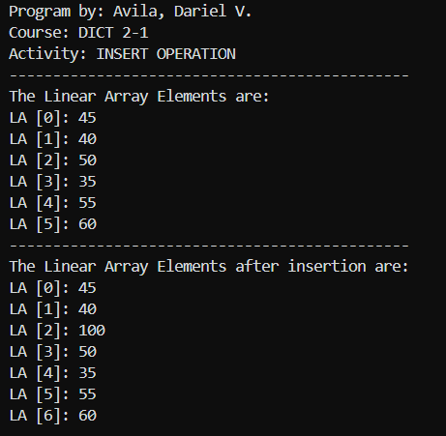

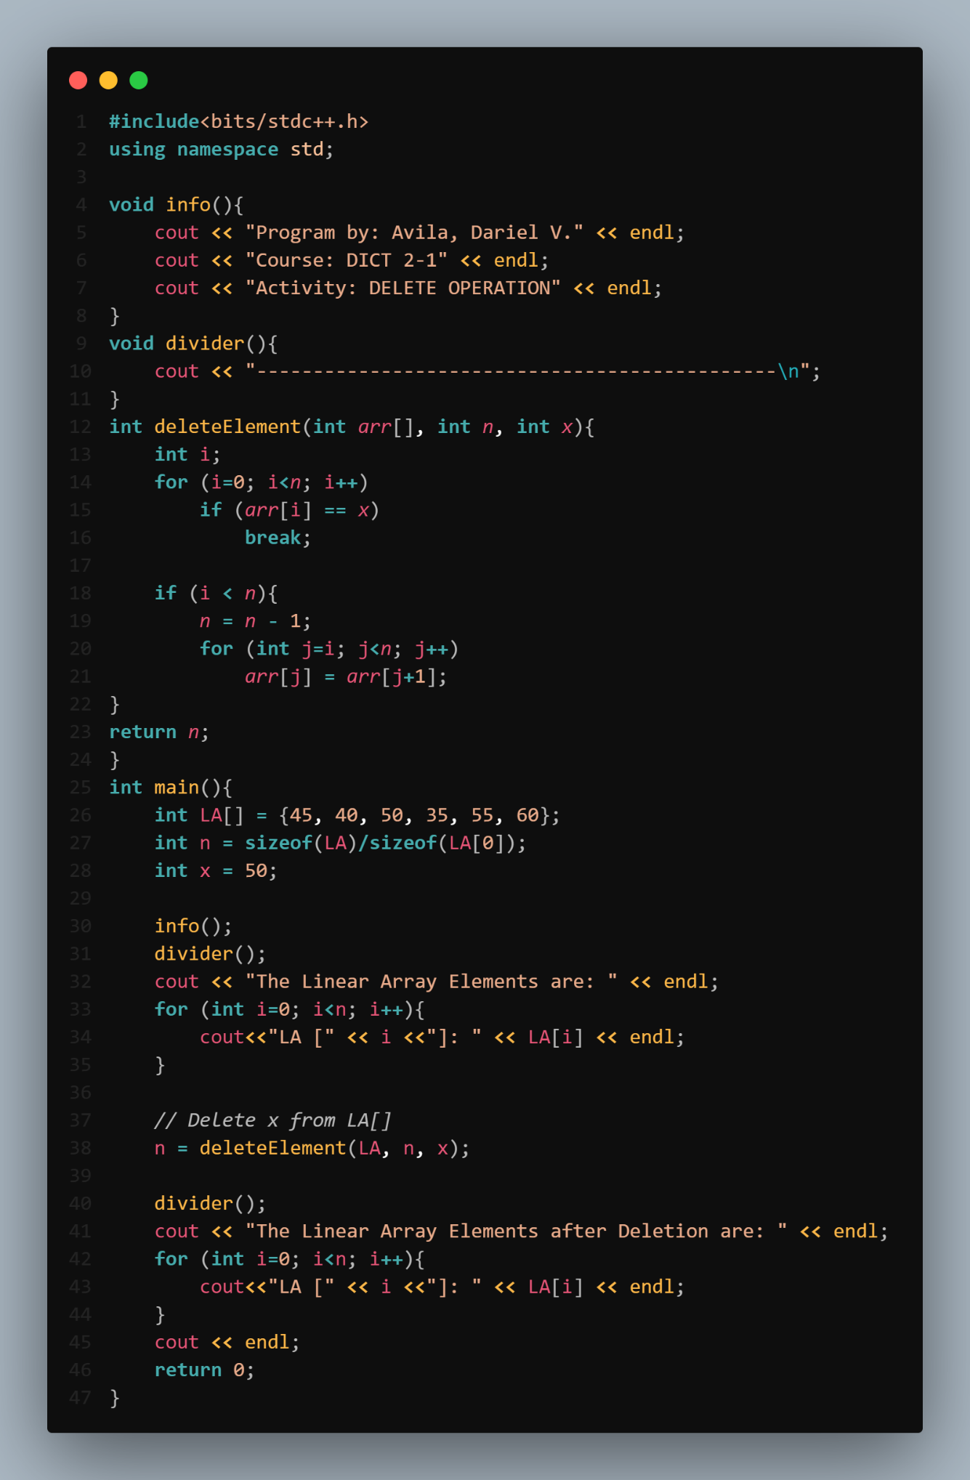Activity 2: **DELETION – Array**

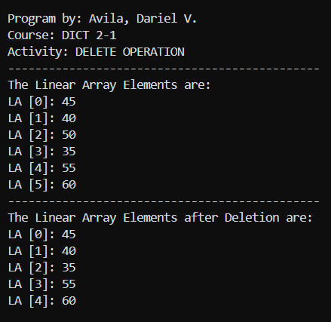

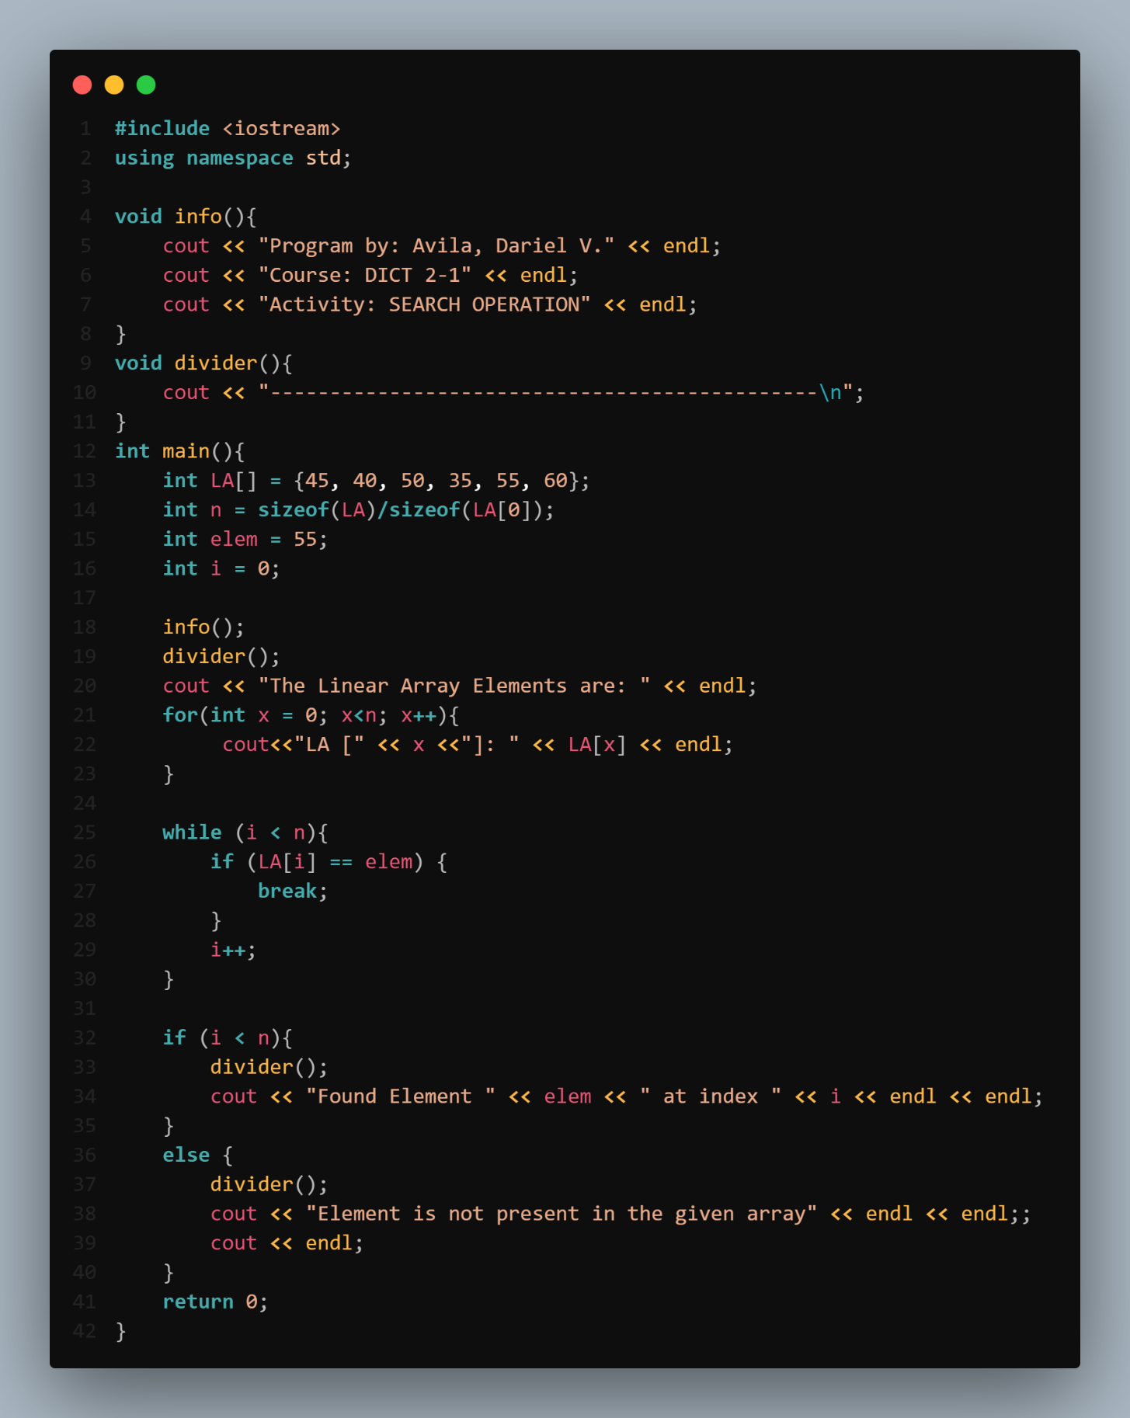Activity 3: **SEARCH – Array**

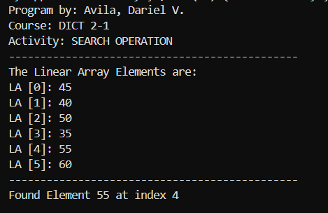

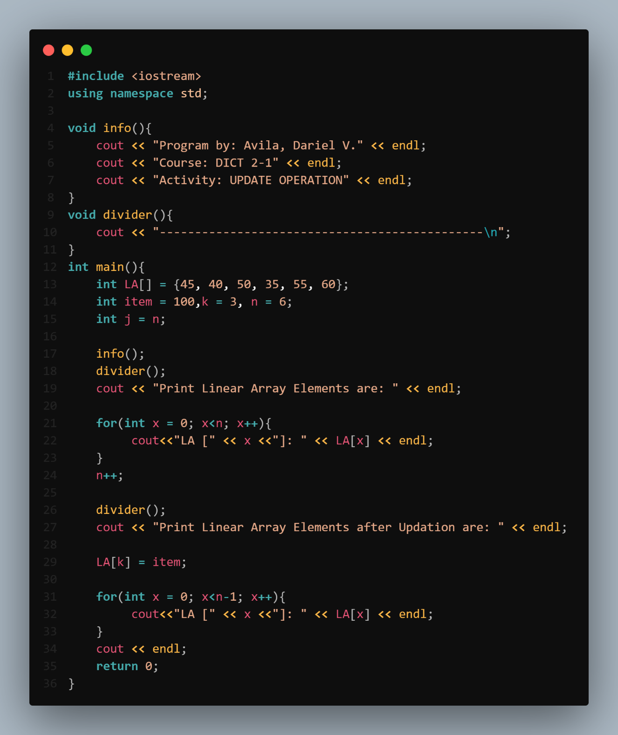Activity 4: **UPDATE – Array**

